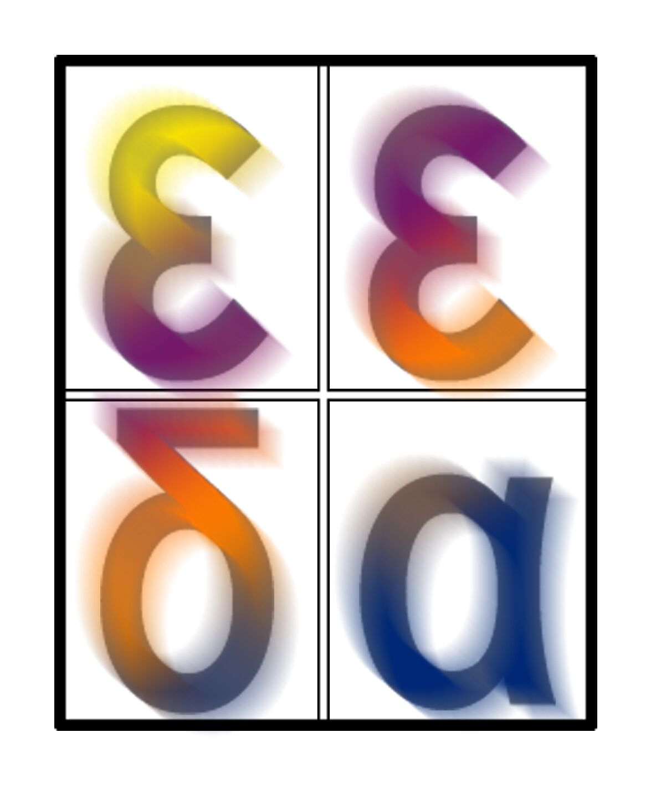
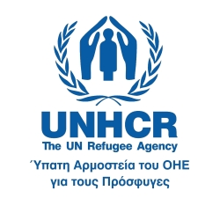

Athens, 23 October 2012

Press Release
Racist Violence Recording Network presents its findings
about racist violence in Greece

Athens – The Racist Violence Recording Network* presented today the extremely worrying findings resulting from the recording of acts of violence during the first nine months of 2012, during a very well-attended Press Conference.

The Network, which apart from the UN Refugee Agency and the National Commission for Human Rights, numbers 23 non-governmental organizations and other bodies, documented on the basis of the victims’ testimonies, 87 incidents of racist violence against refugees and migrants from January to September 2012. More than half of these incidents are connected with extremist groups that act in an organized and planned manner, while in certain cases, the victims or witnesses to the attacks reported that they recognized persons associated with Golden Dawn party among the perpetrators.

The recorded attacks are characterized by increased violence and victims report the use of weapons, such as clubs, crowbars, folding batons, chains, brass knuckles, knives and broken bottles during the attacks, as well as the use of large dogs. There is a distinct category of 15 incidents where police and racist violence are interlinked

According to the Network, the main problems rest with the inability or unwillingness of the criminal investigation authorities to record racist violence incidents, to investigate the cases thoroughly and to arrest the perpetrators or, at times, with the practice of deterring the victims of the attacks who do not have legal residence papers from reporting racist violence incidents to the police.

Based on the conclusions drawn, the members of the Network have made specific recommendations to the Greek state (Ministry of Public Order and Citizen Protection and Ministry of Justice) in order to fight racist violence.

In his speech during the Press Conference, the Head of the UNHCR Office in Greece, Mr. Giorgos Tsarbopoulos, noted: "What we are experiencing today is a return to barbarism, human life’s loss of value, the questioning of the constitutionally inscribed principles of equality and non-discrimination, as well as the challenging of the rule of law and democracy, by organized attack groups acting like a state within a state. Therefore, by defending the obvious for refugees and migrants (the right to life and human dignity), we defend democratic institutions and human rights of the Greek society as a whole".

The former President of the National Commission for Human Rights, Mr. Kostis Papaioannou, warned: “Today we are raising the alarm because racist violence and neo-nazi threat have been generalized and threaten the mere functioning of democracy. Racist violence is not only geared towards migrants but also against several segments of the population as well as against social cohesion. We call on the Greek Government to assume its responsibilities having as first priority the dismantling of neo-nazi groups in the Hellenic Police.”

Referring to the experience of Doctors of the World (MdM) with victims of racist attacks, the President of the organization, Mr. Nikitas Kanakis, said: “Medical clinics of MdM are today the ultimate shelter for frightened migrants who are targeted on a daily basis, suffering violence, humiliation and fear. Participation in the Network is the least a humanitarian organization can do if it refuses to ignore seeing what is happening. Today we are uniting our voice with all those who are against fascism in the Greek society. MdM oppose the use of humanitarian assistance for the promotion of policies of hatred which fuel racist attacks. We repeat and insist that against “for Greeks only” we say “wherever there are human beings”.

The President of the Greek Forum of Migrants, Mr. Moavia Ahmed, reported that attacks take place against recognized migrants’ associations, “the most lawful part, the main communication channel of migrants with the state and the society”. He also said that migrants are in great fear, referring to the community of Moroccans that has suspended Arabic lessons that used to take place in Athens out of fear of attacks.

The event was moderated by the journalist, Ms. Marilena Katsimi, while a UNHCR video with the testimony of a victim of racist violence was also screened.

The whole Press Conference was livestreamed via UNHCR Greece website, www.unhcr.gr, as well as via the redesigned web platform of UNHCR's campaign "1 victim of racist violence is too many", www.1againstracism.gr.

Findings of the Racist Violence Recording Network for the period January – September 2012 are available at the following link: http://goo.gl/g8LTV

* The Racist Violence Recording Network was set up in October 2011 at the initiative of the National Commission for Human Rights (NCHR) and the Office of the UN High Commissioner for Refugees in Greece (UNHCR). Currently, the following non-governmental organisations and bodies participate in the Network: Aitima, Antigoni – Information and Documentation Centre on Racism, Arsis, Doctors of the World, Amnesty International, Network for the Social Support of Refugees and Migrants, Hellenic League for Human Rights, Greek Helsinki Monitor, Greek Council for Refugees, Greek Forum of Migrants, Greek Forum of Refugees, Human Rights Commission of the Bar Association of Rhodes, “Babel” Day Centre, Movement for the Support of Refugee and Migrant Rights (Patras), LATHRA; Solidarity Committee for Chios refugees, METAdrasi, Integration Centre for Working Migrants - Ecumenical Refugee Program, Group of Lawyers for the Rights of Refugees and Migrants, Group of Lawyers for the Support of Refugee and Migrant Rights (Thessaloniki), Association of Afghans United in Greece, Forum of Migrants in Crete, i-RED Institute for Rights, Equality and Diversity and PRAKSIS, as well as the Greek Ombudsman as observer. The Network aims at combatting racist violence, making recommendations to the State and sensitizing public opinion.

END

For further information, please contact:

- Ketty Kehayioylou, Public Information Officer, UNHCR, 210 6726462-3
- Tina Stavrinaki, Legal Officer, NCHR, 210 7233216

